HOW TO REGISTER
Via https://registration.officialshq.com the umpires can start registering for an umpire body.
There is a short YouTube video created by the OfficialsHQ: https://www.youtube.com/watch?v=vu3pgnJojGw
Part 1 – Account Creation
Step 1 - Account
      - Add a valid email address.
If for some reason the email address is already known to the system a warning will be displayed and the registration process cannot be continued. Please use this email address to login to your account on https://app.officialshq.com.
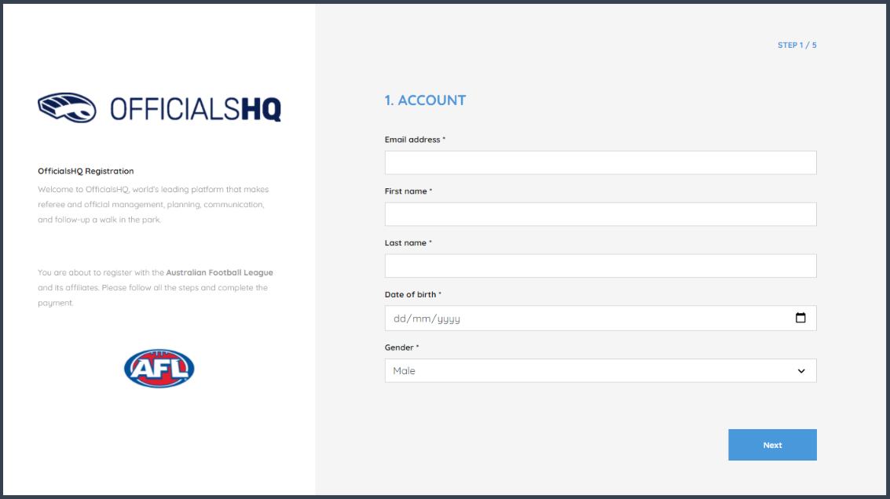
      - First Name
      - Last name
      - Date of Birth
      - Gender

Step 2 – Address & contact
All required address and contact information should be added.
      - House number
      - Street
      - Suburb
      - Postcode
      - Select State from dropdown
      - Add a mobile number

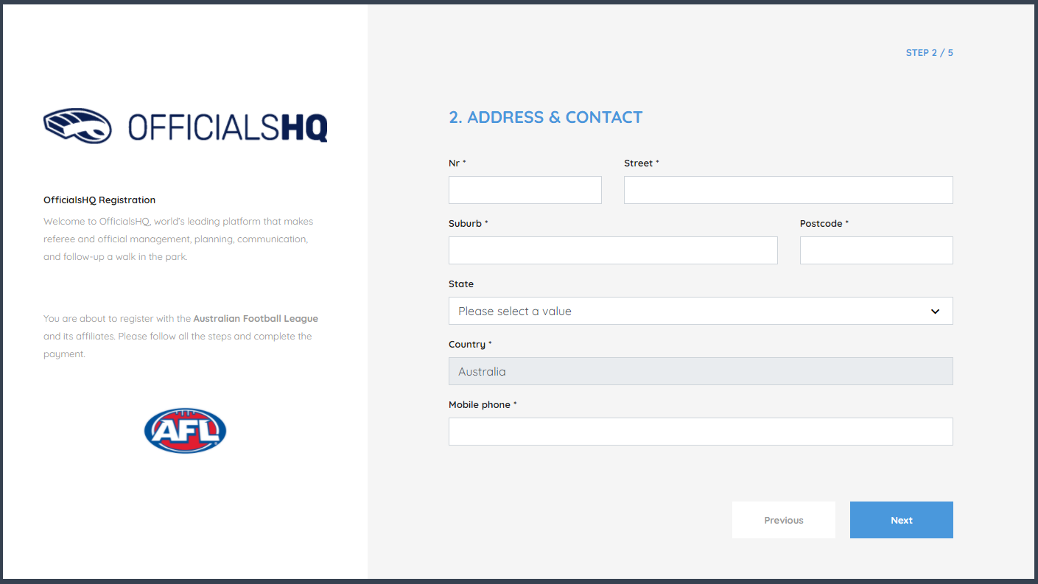
Step 3 – Role preference
The umpire must select at least one umpire club and role combination to register to the system. It is possible to add multiple umpire club/role combinations at one time.
For every umpire club/role the user whishes to add:
      - Select the state (SA)
      - Select the umpire club/league you intend to umpire with
(Select your League with the UC prefix e.g UC-Barossa)
      - Select the role
(Field, Boundary Goal etc.)
      - Click “Add role preference”
      - Note – if umpires are interested in doing more than one discipline or intend to umpire across multiple leagues they can add further role preferences but need to do this at registration – once registered they will be unable to change their preferences without contacting SANFL

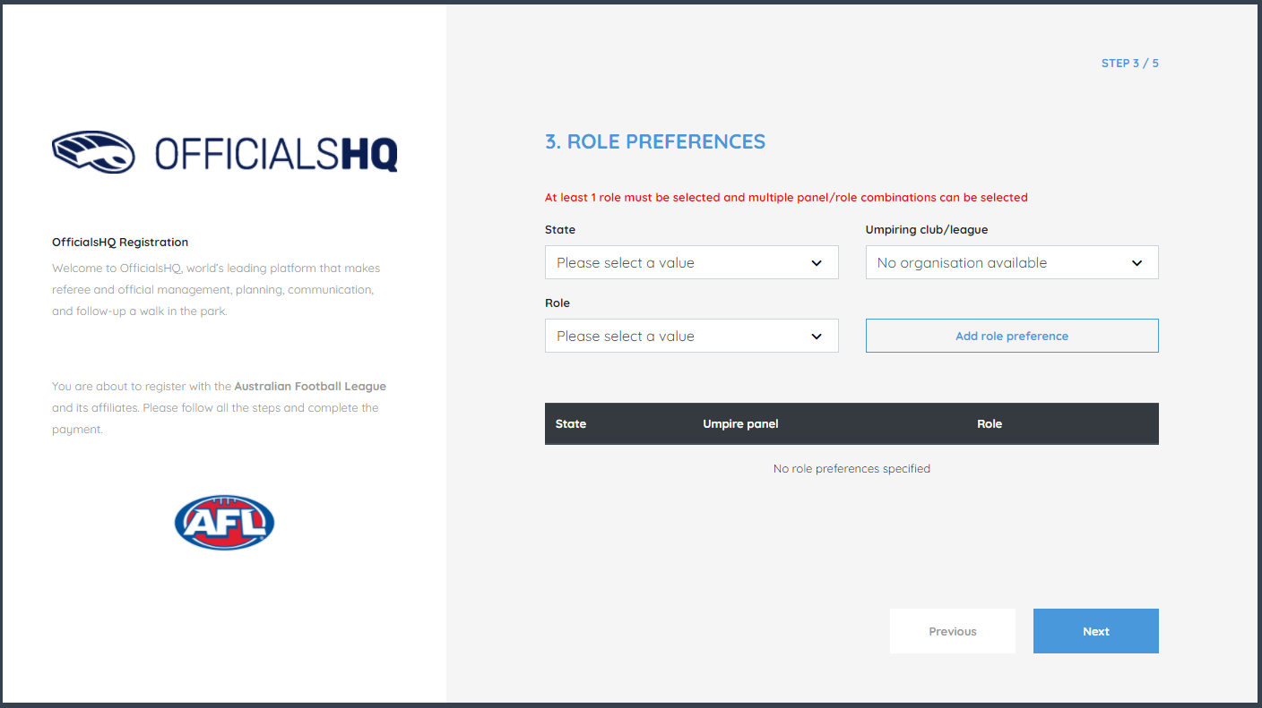

Step 4 - Summary
A summary will be shown with all data that was entered by the user.
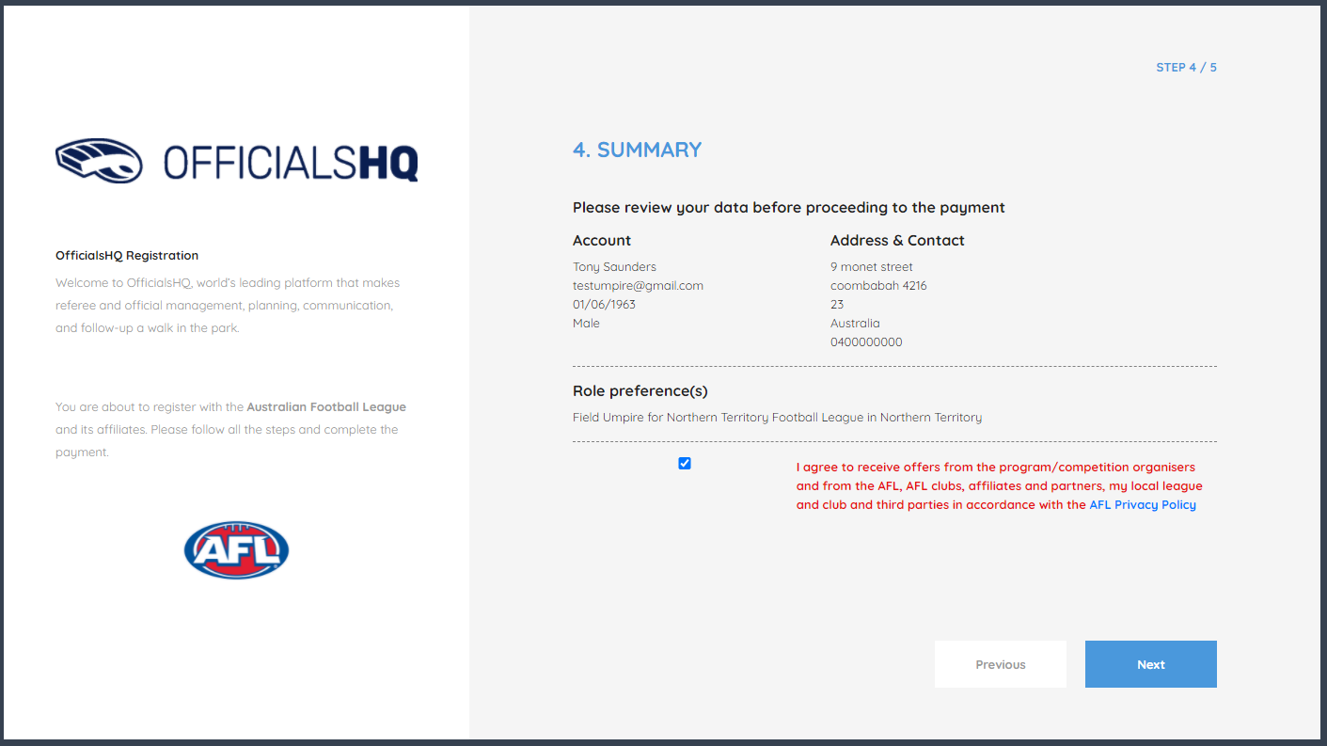

Step 5 – Completing registration
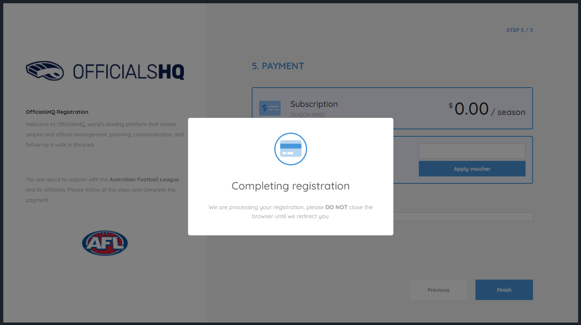
Step 6 – Account Created
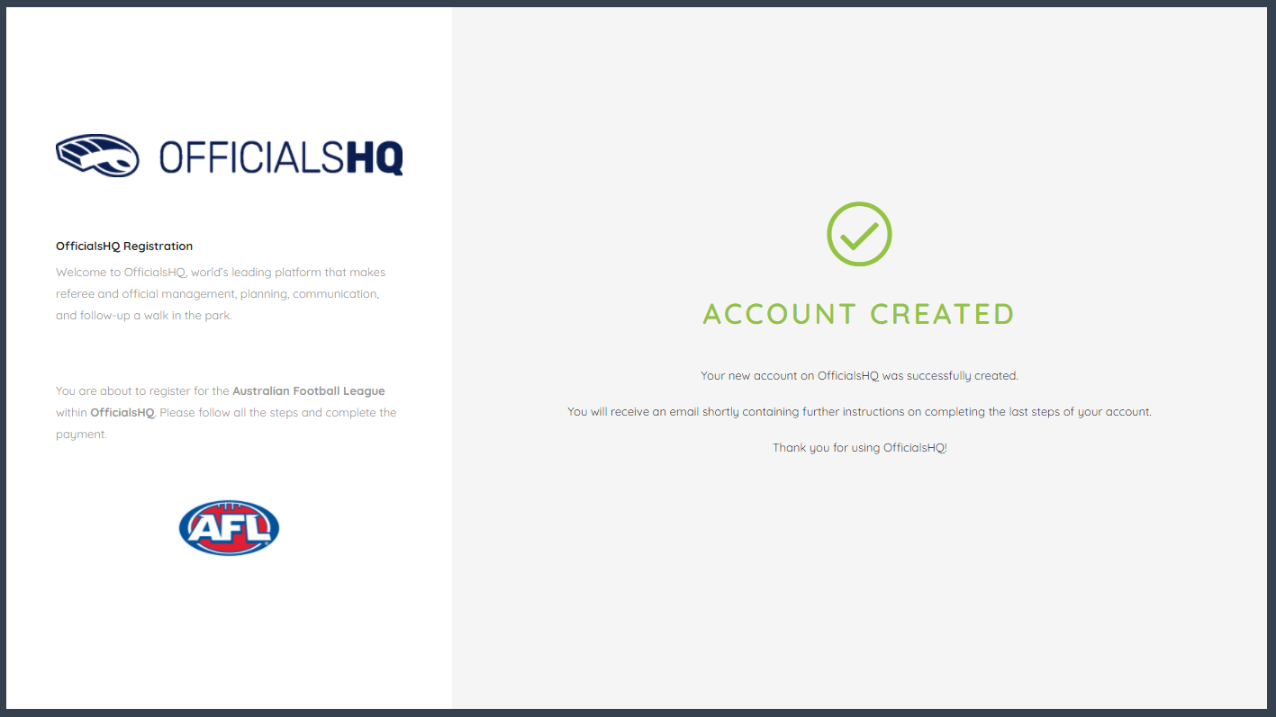
Step 7 – Email confirmation
An email (as shown below) with further details wil be sent to the registered email address as confirmation.
      - Check spam/junk in email account if not received
      - If still NOT received email umpire.afl@afl.com.au & ask for it to be re-issued
      - DO NOT proceed until email is received

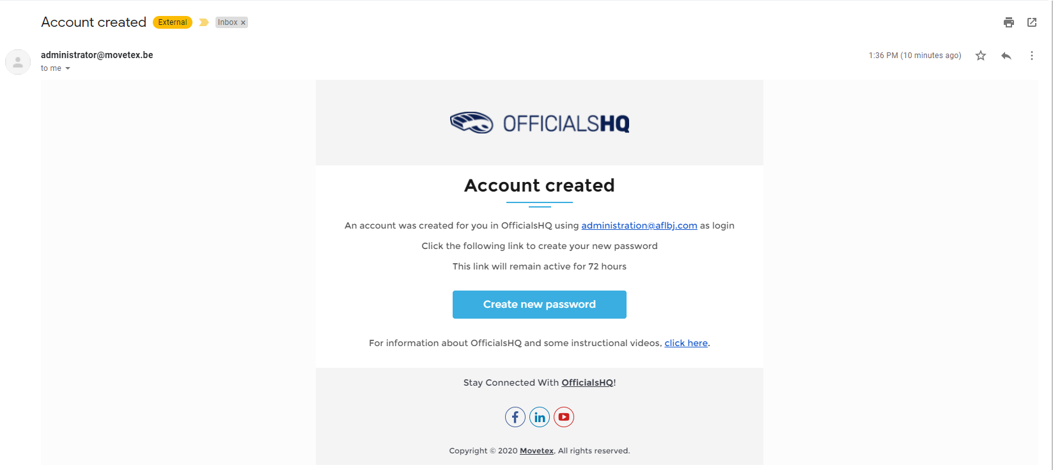

Step 8 – Create password
The email you’ll receive from OfficialsHQ will allow you to set your password. Click on “Create new password” to create a password.

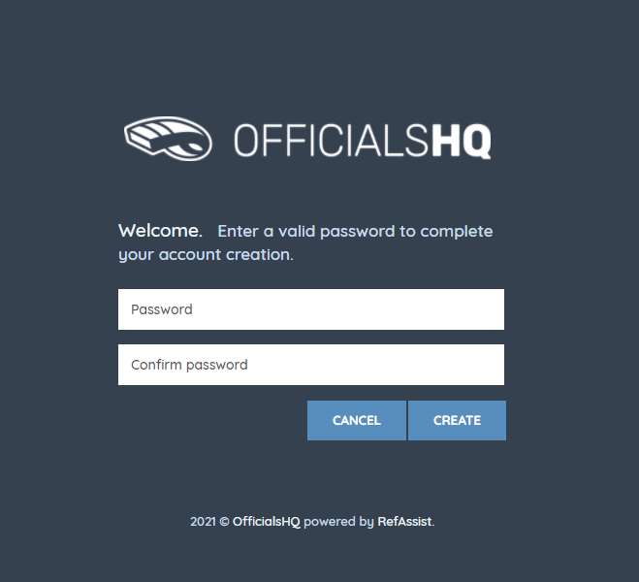

Step 9 – Email confirmation to access to OfficialsHQ
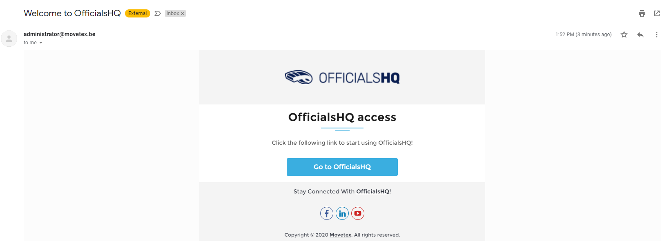

Step 10 – Login to OfficialsHQ
From now you’ll be able to login to OfficialsHQ through: https://app.officialshq.com Fill out the username (email address) and the password the user has created to enter OfficialsHQ.

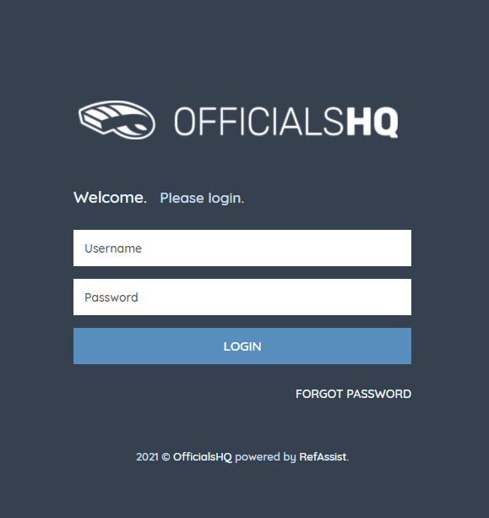

Part 2 – Account Completion
Step 11 - Club Association
When login on to their OfficialsHQ account for the first time, newly registered users have to provide detailed account
- No club is to be selected if you are not playing
- Select your football club you play for (REQUIRED)

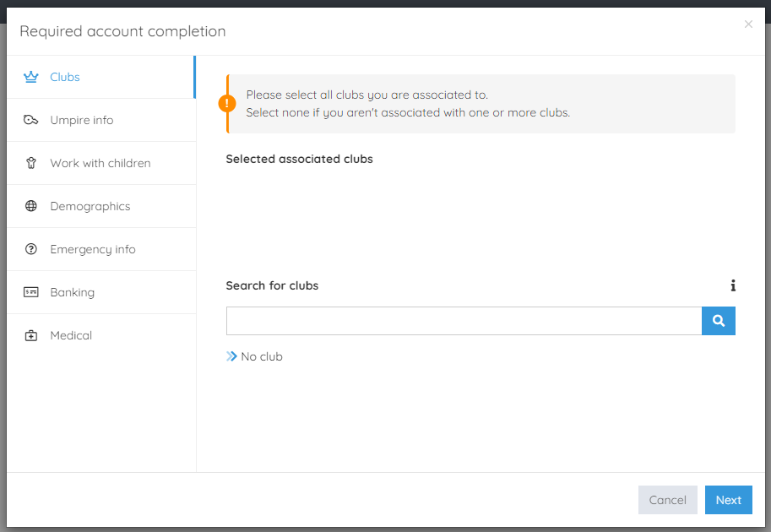
Step 12 – Umpire information
All 3 fields must be entered
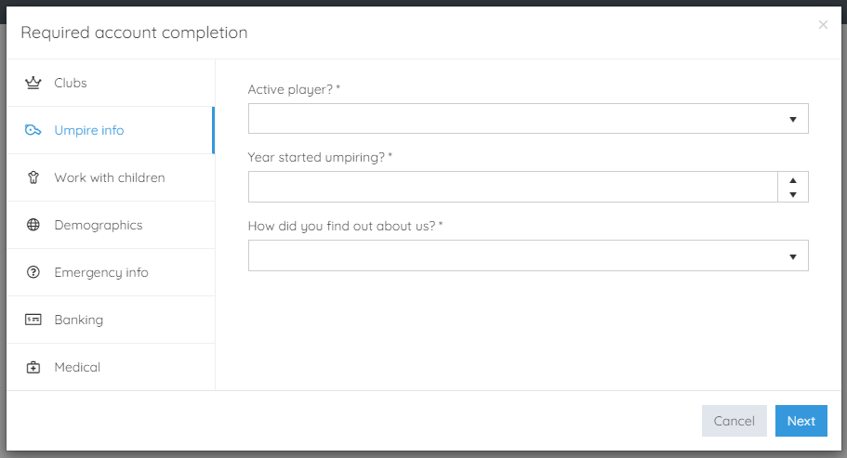

Step 13 – Working with Children this a MANDATORY field & must be completed
- If you DO NOT have a Working with Children Check (WWCC), the question “have you obtained a working with chilrden check or do you otherwsie meet the working with chirdlren check requirements in your State or Territory”, you are required to select 'No”.
  - Umpires who applied and have only supplied their League with their ‘AP’ or ‘SC’ number, must mark ‘NO’

- To enter “YES” to the WWCC question, you must have supplied your League with evidence that you have obtained your WWCC and show your SRN number. Evidence includes:

  - Department of Human Serivce WWCC Certificate
  - Email from Department of Human Services
  - SRN Number

- You should also register your WWCC under the ‘accreditations’ section of Officials HQ

- If you have supplied your WWCC previously, then you have meet with WWCC requirements in SA, provided your WWCC is still valid (5 year expiry from issue date)

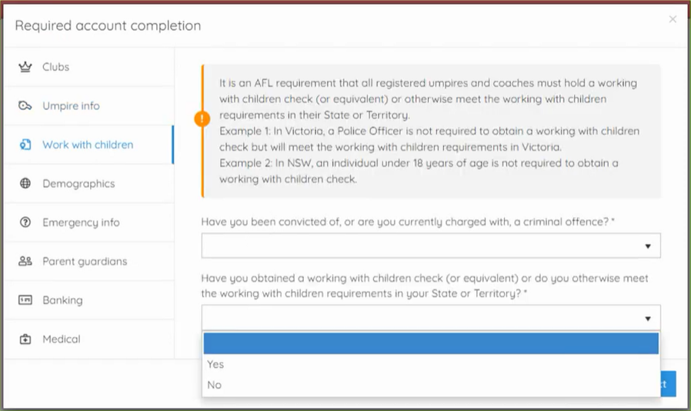
The SANFL Umpiring Department can assist you with your Working with Children Check if you are yet to apply or obtained a check
Step 14 – Demographics
        - Country of birth
        - Born overseas?
        - Origin

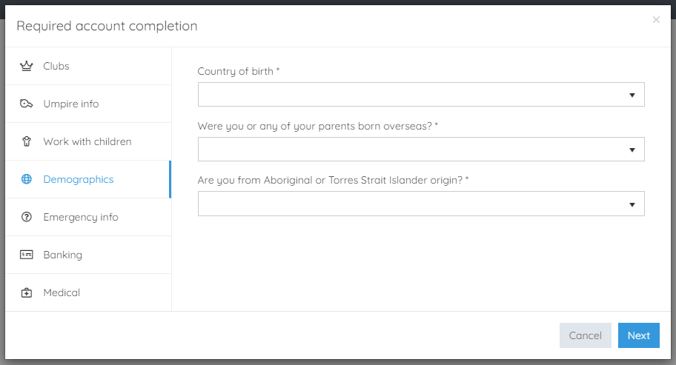

Step 15 – Emergency contact
A user can add an emergency contact. This is the first person that will be contacted when a problem occurs. An name, telephone number and the relationship with the user are required.
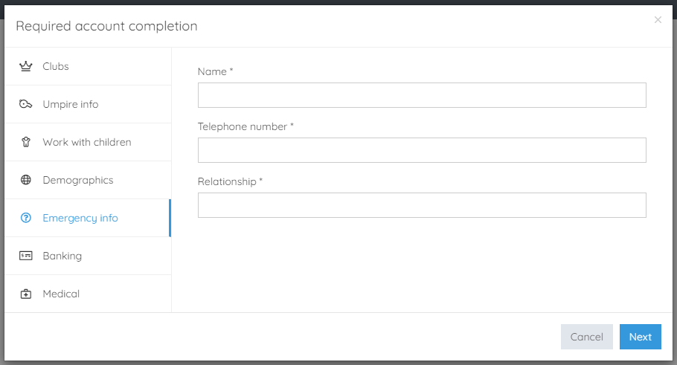
Step 16 – Banking this a MANDATORY field & must be completed
This is a mandatory field set by OfficialsHQ. This must be complete correctly or the set-up will not be completed. If you have issue supplying your bank details please just enter BSB: 000-000 Account number: 0000 0000 unless your league is using Officials HQ to pay you, in which case you must supply your account details or you will not be paid.
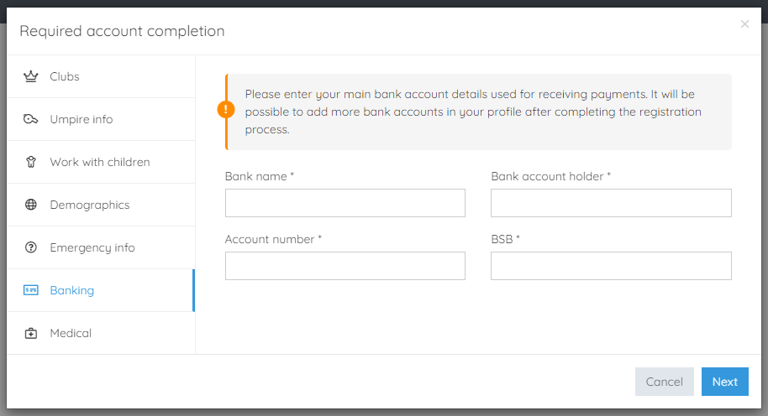

Step 17 – Medical
A user can choose to share some medical information with the league administration (allergies, disabilities, …)

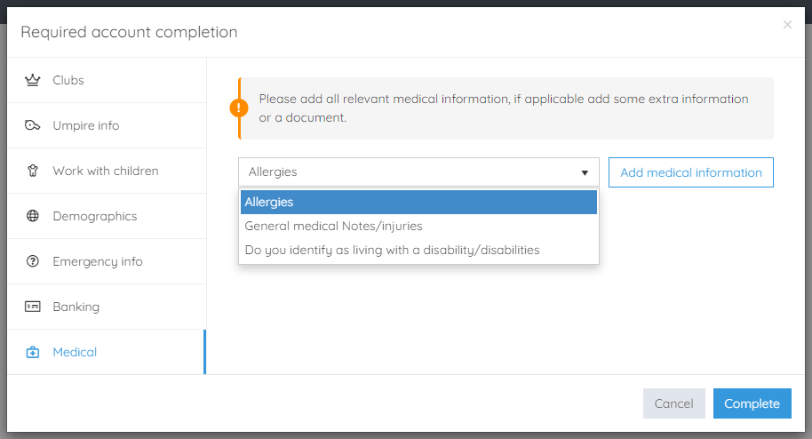

Step 18 – Terms and Conditions
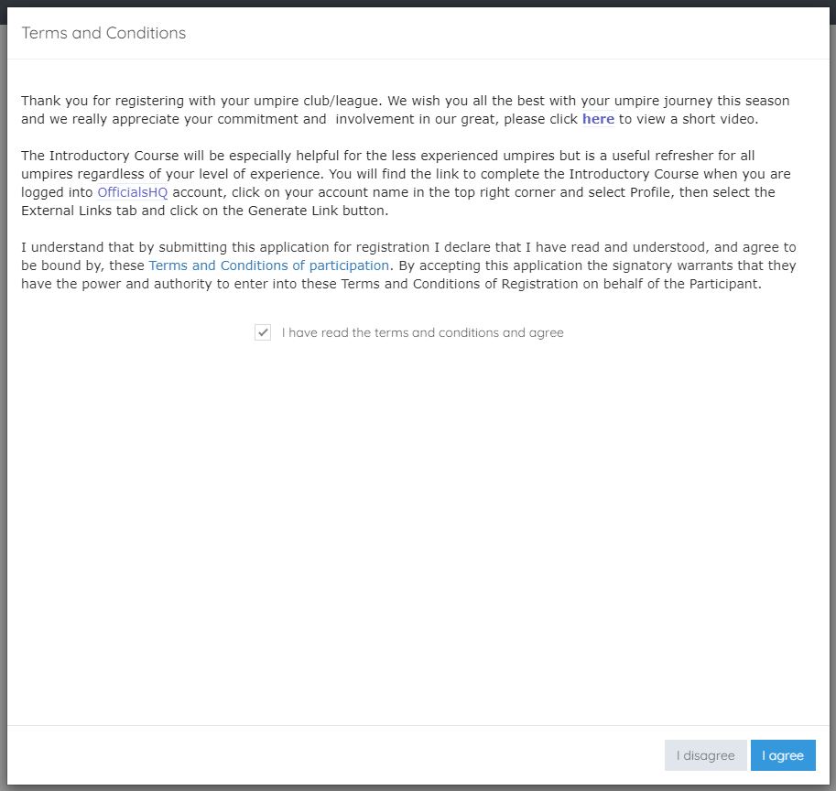

Step 19 – OfficialsHQ Dashboard
Your registration is now complete

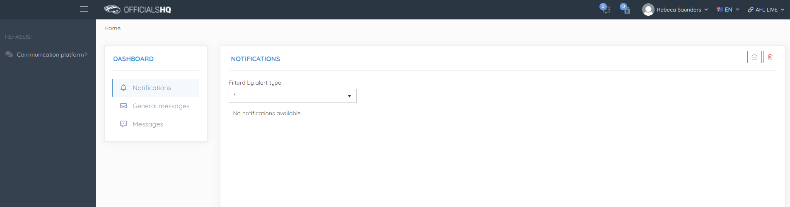

LOGGING IN TO OFFICIALSHQ
LIVE - https://app.officialshq.com

