HOW TO REGISTER
Via https://afl.us20.list-manage.com/track/click?u=3e967be278c0b19184d274a9b&id=e65164eded&e=6e06eb99f0 umpires can start registering for an umpire body.
There is a short YouTube video created by the OfficialsHQ to assist you with the re-registration process: https://www.youtube.com/watch?v=flNXAo4jT34
Part 1 – Re-Registration
Step 1 – Log In as per 2023
When re-registering as an umpire in 2024:
- Enter your log in details as per your regisration for 2023

DO NOT START A NEW OFFICIALSHQ ACCOUNT
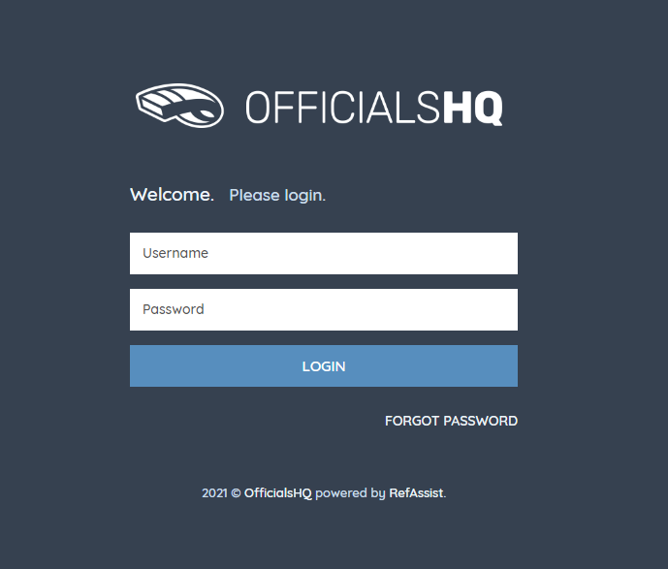

Step 2 – Required Re-Registration
Umpires will be promoted to the re-registration page. All details from the 2023 season will be ‘pre-filled’:
- Please check the ‘pre-filled’ details are correct
- Any changes to your contact detials, you can edit

If you wish to change your log-in email address, you will need to contact SANFL to change your login email address matthew.northcott@sanfl.com.au

Step 3 – Role preference this a MANDATORY field & must be completed
The umpire must select at least one umpire club and role combination to register to the system. It is possible to add multiple umpire club/role combinations at one time.
For every umpire club/role the user whishes to add:
      - Select the state (SA)
      - Select the umpire club/league
(Select your League eg. Adelaide Plains Umpires)
      - Select the role
(Field, Boundary Goal etc.)
      - Click “Add role preference”
      - Note – if umpires are interested in doing more than one discipline or intend to umpire across multiple leagues they can add further role preferences but need to do this at registration – once registered they will be unable to change their preferences without contacting SANFL

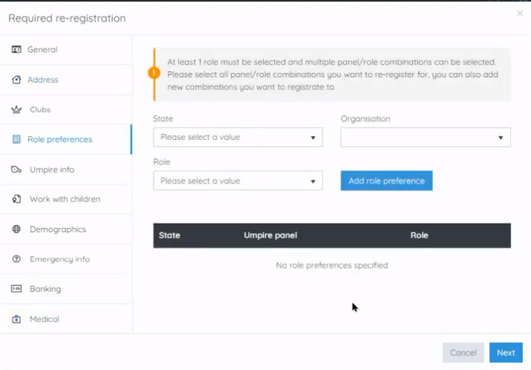

Step 4 - Working with Children this a MANDATORY field & must be completed
- If you DO NOT have a Working with Children Check (WWCC), the question “have you obtained a working with chilrden check or do you otherwsie meet the working with chirdlren check requirements in your State or Territory”, you are required to select 'No”.
  - Umpires who applied and have only supplied their League with their ‘AP’ or ‘SC’ number, must mark ‘NO’

- To enter “YES” to the WWCC question, you must have supplied your League with evidence that you have obtained your WWCC and show your SRN number. Evidence includes:

  - Department of Human Serivce WWCC Certificate
  - Email from Department of Human Services
  - SRN Number

- You should also register your WWCC under the ‘accreditations’ section of Officials HQ

- If you have supplied your WWCC previously, then you have meet with WWCC requirements in SA, provided your WWCC is still valid (5 year expiry from issue date)

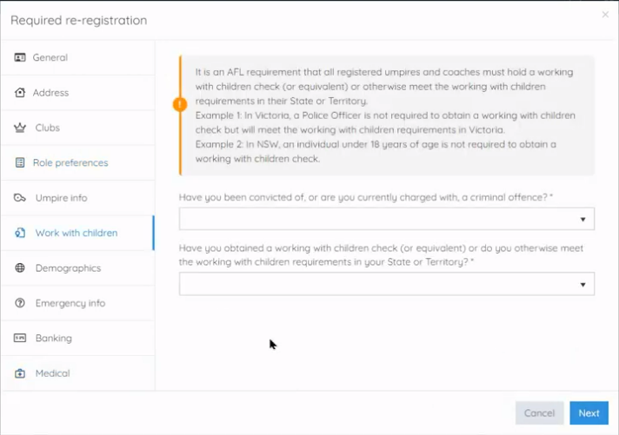

Any questions regarding WWCC or if you are having issues completing the application, please contact SANFL Umpiring Recruitment, Development, Retention Lead at matthew.northcott@sanfl.com.au

Step 5 – Banking this a MANDATORY field & must be completed
This is a mandatory field set by OfficialsHQ. This must be complete correctly or the set-up will not be completed. If you have issue supplying your bank details please just enter BSB: 000-000 Account number: 0000 0000 unless your league is using Officials HQ to pay you, in which case you must supply your account details or you will not get paid.
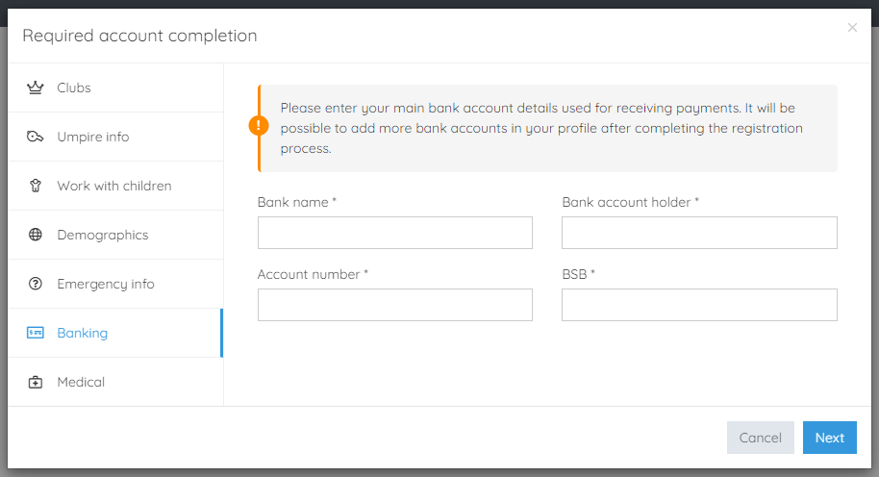

Step 6 – Medical
A user can choose to share some medical information with the league administration (allergies, disabilities, …)

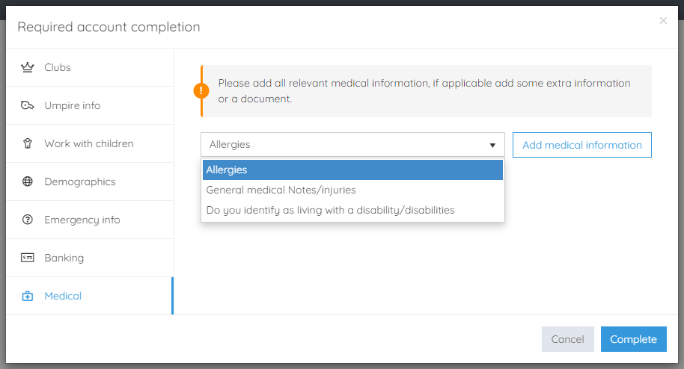

Step 7 – Terms and Conditions
To complete the registration process, you are required to agree to the terms and conditions
- Note: If you do not agree to the ‘Terms & Conditions’, you will be logged out and and will need to start the process again

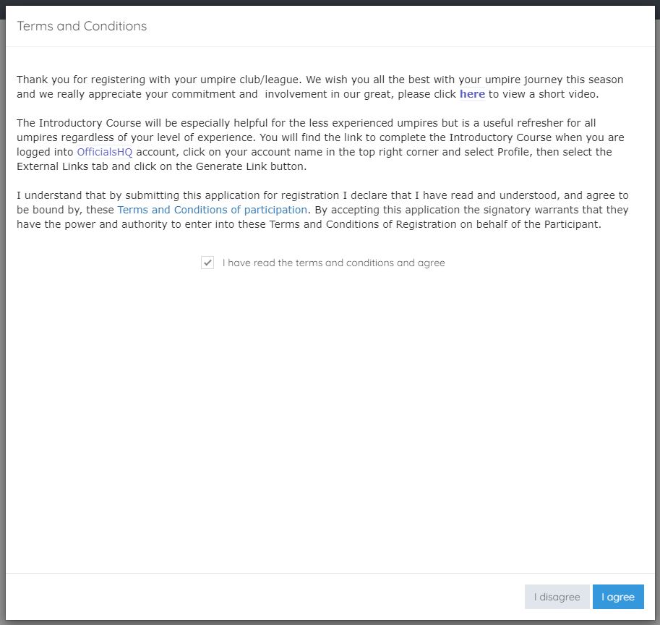

Step 8 – OfficialsHQ Dashboard
Your registration is now complete

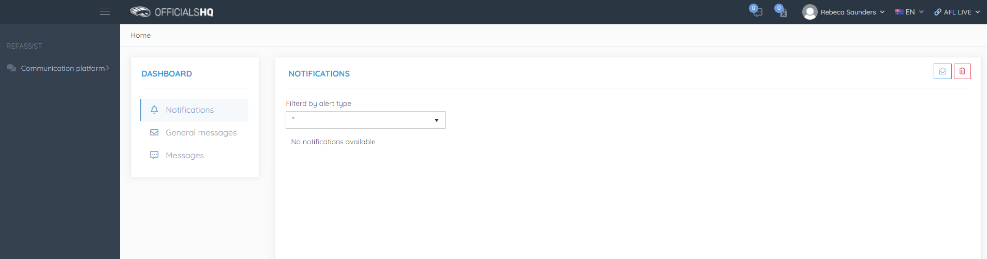

Step 9 - LOGGING IN TO OFFICIALSHQ
Log into OfficialsHQ at the following URL:
https://app.officialshq.com

